US7: Entering Giveaways

1. Client will be presented with the product/s in giveaway as soon as entering the site.
2. Client can see the details on the giveaway such as the timeframe of applying and end-date.
3. If not already, client needs to go through the process of signing up with his/her personal information to then be able to enter the giveaway.
4. Client needs to click “Enter giveaway”.
5. Client needs to fulfill all listed requirements before officially being part of the giveaway.
6. Client clicks “Complete”.

US8: Making Custom Orders

1. Client will be presented with “custom orders” page when entering the site.
2. The page will display all brands the shop has partnership with and that offer the custom order option.
3. When interacting with a brand, it will show all available options for personalization.
4. Client can select different options for the selected base instrument such as material (wood types, plastic, carbon fiber), color, string types (guitar, piano, violin, cello), pickups(guitars), tiles(pianos) and so on, where each special part is added to the overall price of the instrument.
5. Upon finishing the custom order, if the client is not logged in already, they are obliged to so the order can be completed.
6. The item is added to cart and the client can continue with the check-out process.

US9: Setting up appointments

1. Client will be presented with “Technical Support” page as soon as entering the site.
2. The page will display alternatives of technical support depending on your instrument (guitar tech-guy will not be the same as the piano or drum tech-guy) or sound system.
3. Upon selecting the specific tech-support, their calendar of appointments will be shown, displaying the hours/days they are free to set up an appointment or are busy with other customers.
4. The customer can select an hour/day for an appointment and click “Confirm Appointment” to finalize it.
5. If the client is not logged in already, they need to log in before the appointment is finalized.
6. Client needs to provide their personal client details in the site to the tech-support upon meeting them so the service can proceed.
7. Upon the instruments fixing/upgrade, a notification is sent to the client via their contact information, along with the bill that can be paid immediately at the shop upon instrument pickup or via the customer account online.

US10: Contacting customer service

1. Client will be presented with “Customer Service” page as soon as entering the site.
2. Upon entering the page, a wide variety of issues that customers usually have will be displayed to the client.
3. Client must be logged in if the concern is regarding one of their orders, personalizations, participations in events or giveaways and other issues with personal client information.
4. When clicking one of these issues, depending on their complexity, the links can either redirect the client to an automated AI with the answers or to workers of the shop (having a hard time logging in can be supported by an AI that walks the client through the process rather than consuming the time of the worker that might deal with something much more complex).
5. Client can state their own issues not displayed in the general tab via the option “Other”.
6. In cases of contacting the workers, clients can either wait for their response online in the site or be notified via their contact information provided from their account.

US11: Leaving a review

1. Client needs to be logged in to leave a review.
2. The option “leave a review” will appear after purchasing a product, receiving customer service, attending an event, or receiving technical support.
3. After clicking the option, the client can leave a “star-rating” and write their review on the item, service or event including a header and their detailed message.
4. Reviews will be public to all other customers and staff and will be taken under consideration for a better experience.
5. Foul or offensive comments in reviews will immediately take the entire review down and the customer dealt with depending on the scale of issue.

Use case diagram: client not signed in

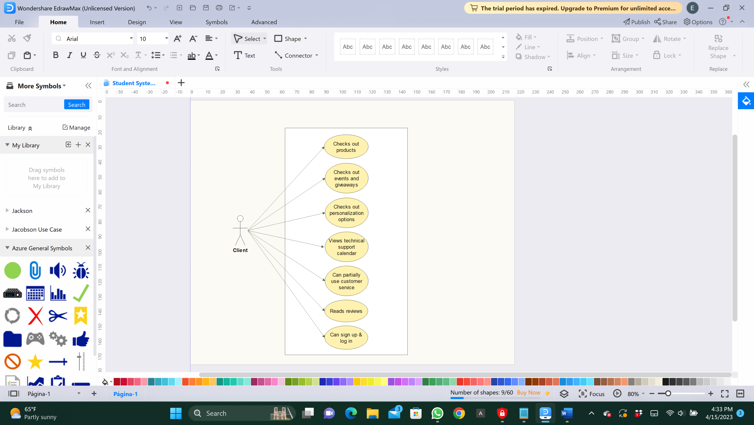

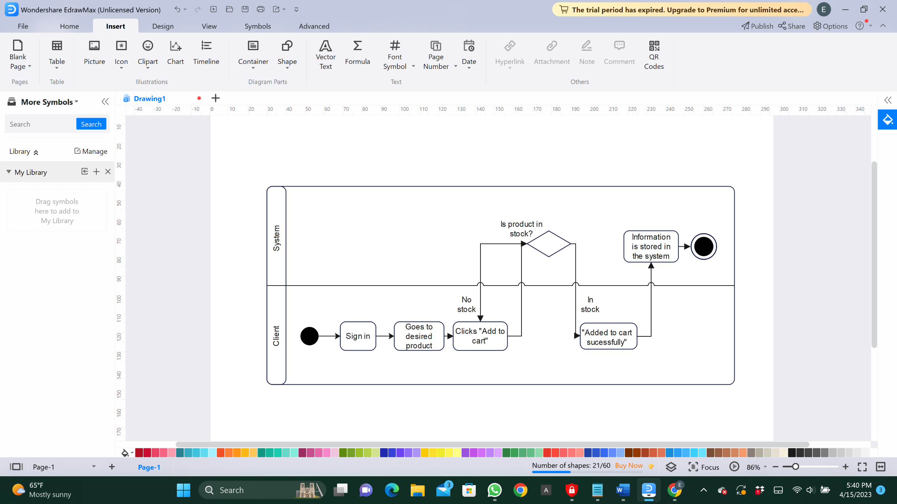Activity Diagram: Client adding to cart

Activity Diagram: Client talking to customer service

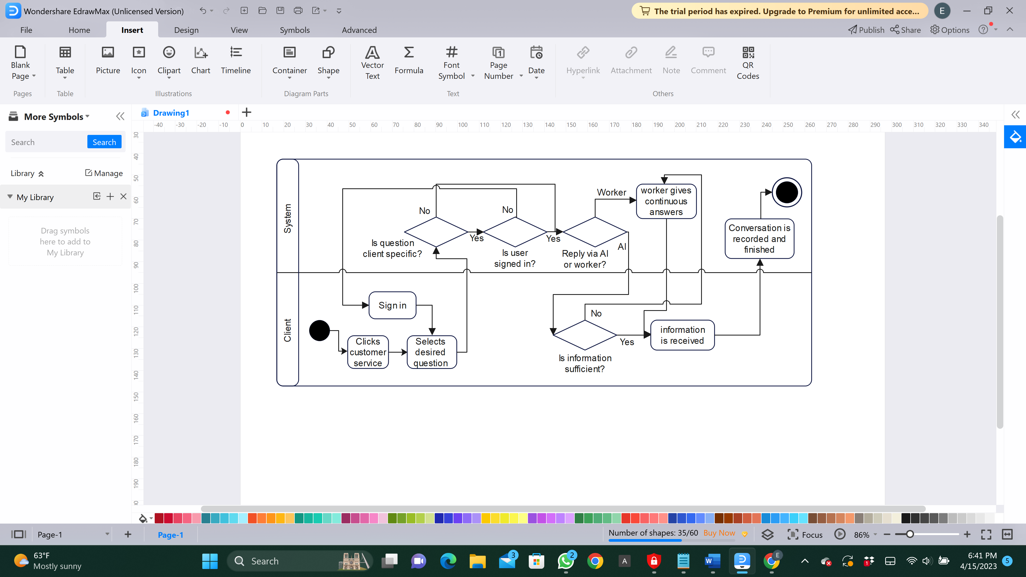

State diagram: Client

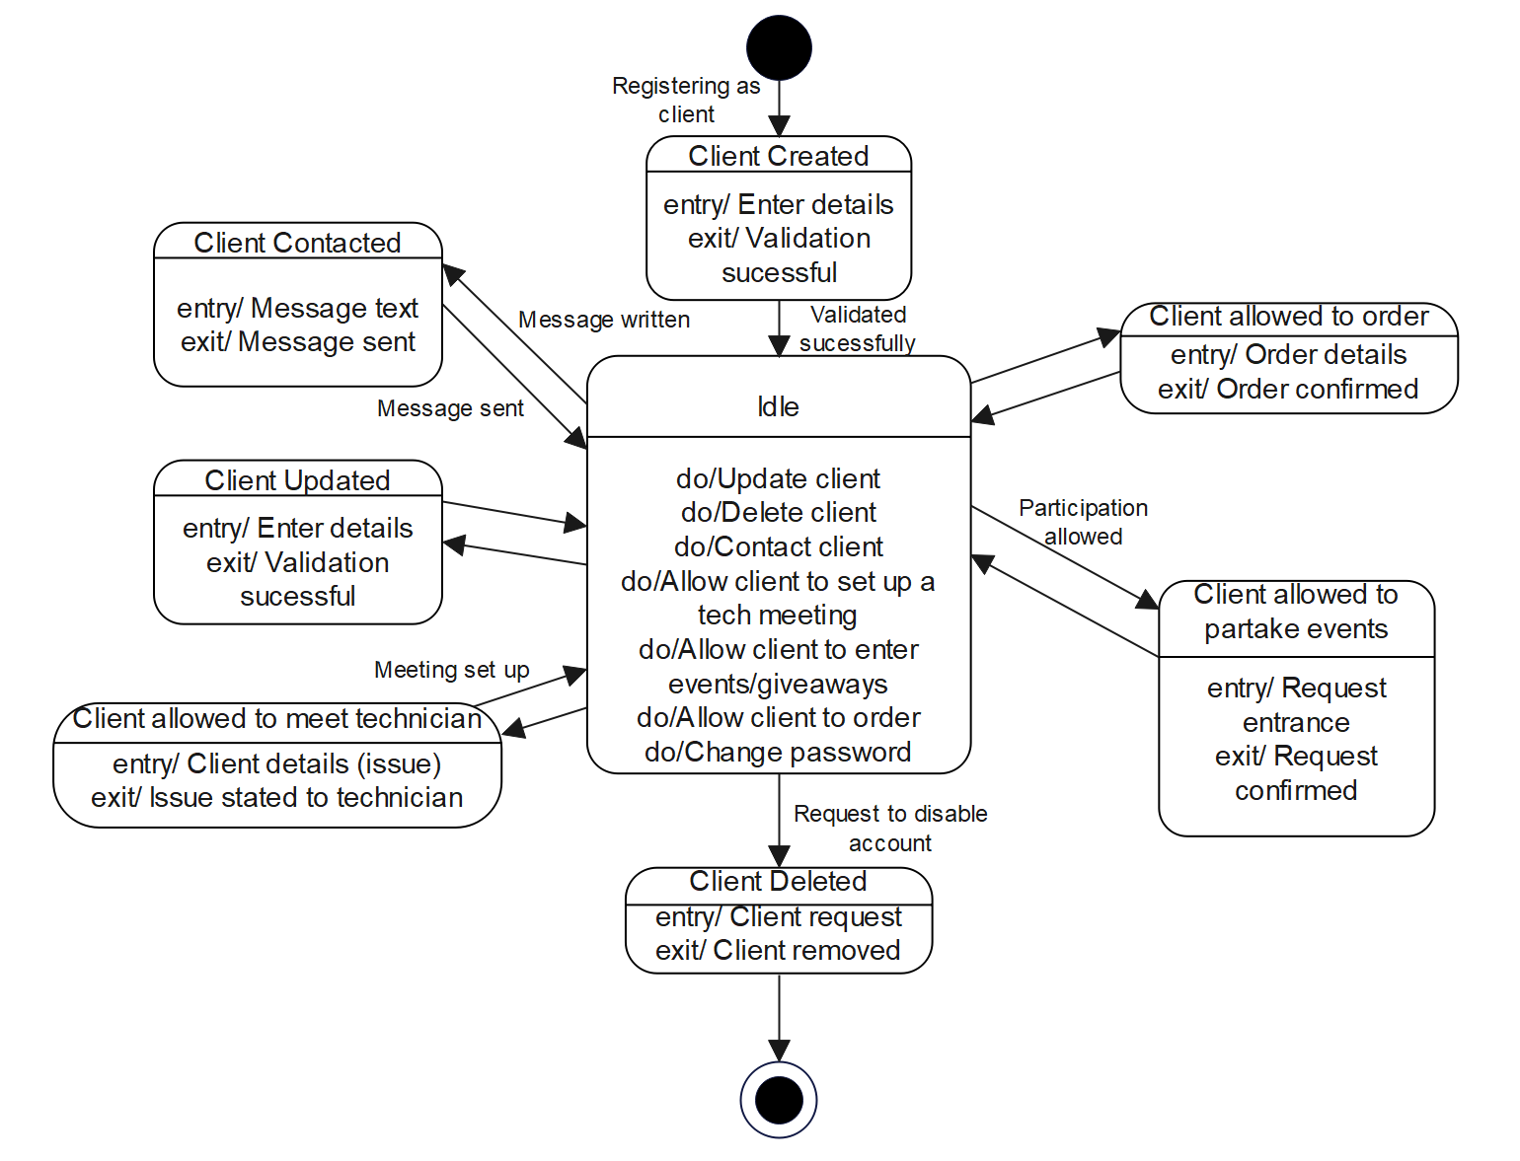

State diagram: Payment

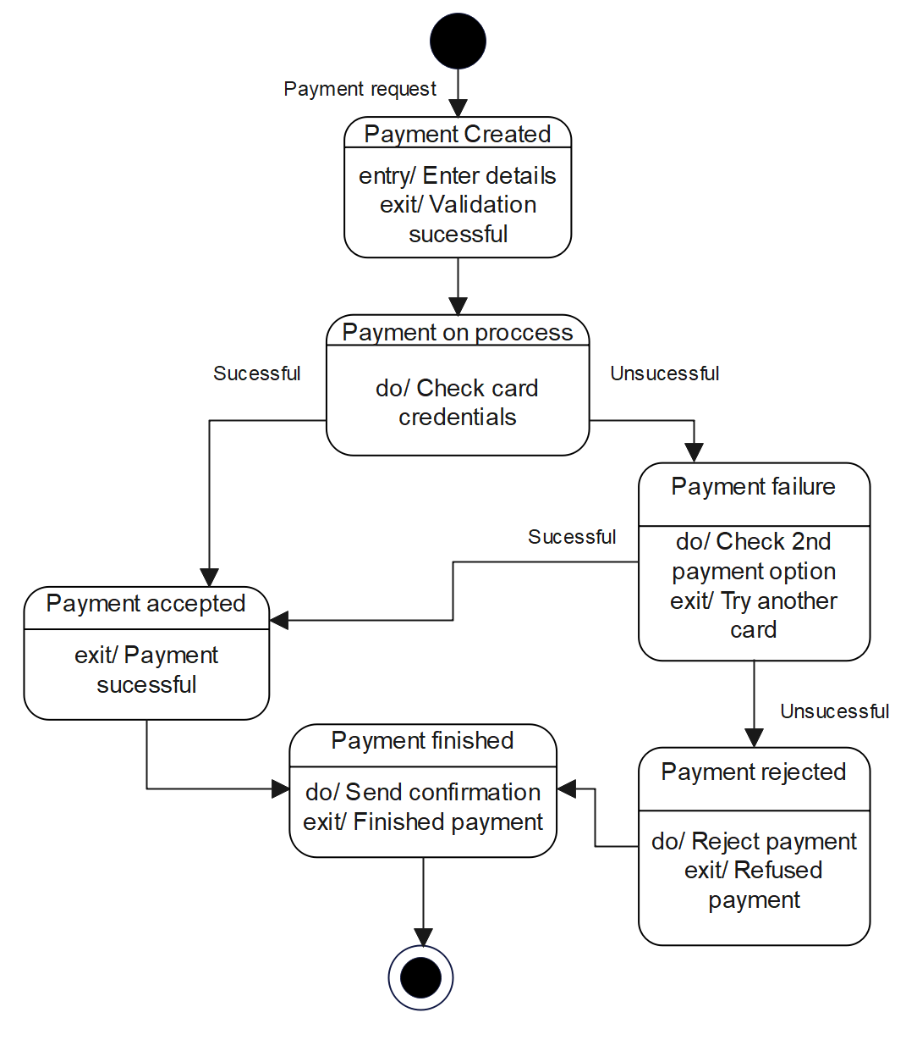

Use Case Nr2: Guest Clients

|  |  |
| --- | --- |
| Use case 2.1: | Guest client checks out products |
| Scope | Music shop app |
| Level | User level |
| Intention Context | Client can browse the catalogue of products offered by the shop |
| Minimum guarantees | Client will not be able to get the entire information about the products |
| Success guarantees | Client will be able to get enough information about the products, but cannot purchase them without an account |
| Primary actor | Guest client |
| Stakeholder’s interest | Guests are drawn to the products offered, to then log in and purchase them |
| Preconditions | The guest client must have entered the app and clicked on the “products” category |

|  |  |
| --- | --- |
| Use case 2.2: | Guest client checks out events/giveaways |
| Scope | Music shop app |
| Level | User level |
| Intention Context | Client can see the events or giveaways happening in the near future |
| Minimum guarantees | Client will not be able to get enough information about the events/giveaways |
| Success guarantees | Client will be informed about the general information of events/giveaways, but cannot participate without an account |
| Primary actor | Guest client |
| Stakeholder’s interest | Guests are drawn to future activities, so they log in and apply for participation |
| Preconditions | The guest client must have entered the app and clicked on the “events” category |

|  |  |
| --- | --- |
| Use case 2.3: | Guest client checks out personalization options |
| Scope | Music shop app |
| Level | User level |
| Intention Context | Client can see options of personalizing/upgrading their instruments |
| Minimum guarantees | Client will not be able to get the entire range of personalization option information |
| Success guarantees | Client will be informed about the general information on personalizing or making custom orders, but cannot purchase them without an account |
| Primary actor | Guest client |
| Stakeholder’s interest | Guests are drawn to the wide range of personalization options and custom orders, pushing them to create accounts and make purchases |
| Preconditions | The guest client must have entered the app and clicked on the “custom orders” category |

|  |  |
| --- | --- |
| Use case 2.4: | Guest client views technical support calendar |
| Scope | Music shop app |
| Level | User level |
| Intention Context | Client can check out the free dates of technician’s schedule to set up a meeting to fix or upgrade their instruments |
| Minimum guarantees | Client will not be able to find a free date that the technician is available |
| Success guarantees | Client will be able to find a free date to meet the technician, but cannot confirm the meeting without an account |
| Primary actor | Guest client |
| Stakeholder’s interest | Guests can see the availability of the technicians; they hurry to occupy free dates by creating accounts and confirming meetings |
| Preconditions | The guest client must have entered the app and clicked on the “tech support” category |

|  |  |
| --- | --- |
| Use case 2.5: | Guest client partially uses customer service |
| Scope | Music shop app |
| Level | User level |
| Intention Context | Client can ask questions to customer service about their issues |
| Minimum guarantees | Client will get general answers from the AI that may or may not be helpful |
| Success guarantees | Client will get general answers from the AI or worker, but cannot ask specific questions without an account |
| Primary actor | Guest client |
| Stakeholder’s interest | Guests want to ask more specific questions about their issues, so they create accounts and increase interactivity with the app |
| Preconditions | The guest client must have entered the app and clicked on the “customer service” category |

|  |  |
| --- | --- |
| Use case 2.6: | Guest client checks out reviews on products |
| Scope | Music shop app |
| Level | User level |
| Intention Context | Client can read the public reviews listed under the products |
| Minimum guarantees | Client will find only star ratings listed below the product they are interacting with |
| Success guarantees | Client will read many reviews from other logged in clients, but cannot leave one themselves without an account |
| Primary actor | Guest client |
| Stakeholder’s interest | Guests read reviews and are tempted to ask questions to other reviewers before buying the product, so they create accounts and increase interactivity with the app |
| Preconditions | The guest client must have entered the app and clicked on the preferred product to then read the reviews |

|  |  |
| --- | --- |
| Use case 2.7: | Guest client can sign up or log in |
| Scope | Music shop app |
| Level | User level |
| Intention Context | Client can create a personal account and log in with that account |
| Minimum guarantees | Upon signing up other existing account problems can occur; upon logging in there can be issues with forgotten emails or passwords |
| Success guarantees | Client will create a new personal account and log in with that account |
| Primary actor | Guest client |
| Stakeholder’s interest | Guest clients will sign in, granting themselves a plethora of purchasing products and services, increasing income for the shop |
| Preconditions | The guest client must have a distinct email and password, not priorly used for another account in the app for the sign up to work |